**How to turn rough lumber into useable pieces of wood**

The purpose of this document is to highlight the procedures required to properly dress a piece of rough lumber.

# Examining your wood

## Size of wood

* Stay away from less than ½” thick (this wood will just flex under pressure as well as chatter as the cutter head engages)
* Stay away from less than 6” long (you will not be able to control the wood in the machines).
* No metal
* Cup side down

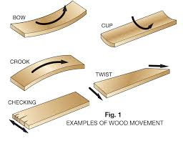

## Grain Orientation

* Try to cut down hill

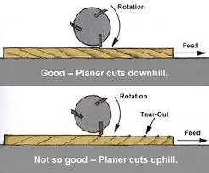

# Jointer

## Purpose

To flatten one surface of a board and to square the other side(s)

## Jointer Parts



## Safety

The following is a list of safety precautions to consider when operating a jointer.

1. Always read and follow the manufacturer’s instructions.
2. Wear ear and eye protection, and do not wear jewelry, long sleeves, or loose clothing.
3. Use paddles, push blocks, and push sticks to keep your hands 6 in. away from the cutterhead at all times.
4. Never joint stock less than 6 in. long.
5. Check the depth of cut before turning machine on.
6. Adjust depth of cut to less than 1/32 in. for material with knots, 1/16 in. for clear material.
7. Keep knives sharp and the machine adjusted properly.
8. Always have the blade guard in place.
9. Stand to one side of the jointer, not directly behind it.
10. Allow the cutterhead to reach full speed before starting a cut.
11. Keep your eyes and undivided attention on the machine while using it.
12. Never feed material with your thumb or fingers on the end of it; keep them on top of the material.

## Procedure

1. Any metal?
2. Ensure cup side is down!!!!
3. Is the jointer set to the correct depth? Recommend 1/32 to 1/16 as a maximum. It is not a race, and after the first few passes you may need to do a correction.
4. Is the fence square?
5. Hearing Aids in?
6. Dust collection started?
7. Joint the face first

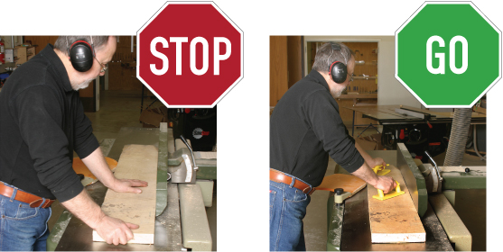

1. Start with rough board.



1. Pass board over jointer, examine board for progress.
2. Continue passing board over jointer until bottom is flat.



1. Joint one side

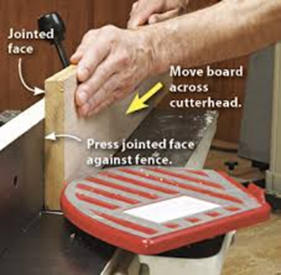

1. Check for cup.
2. Pass board over jointer, examine board for progress.
3. Continue passing board over jointer until edge is square.



1. Typically, you would size the board on table saw to the proper width plus 1/16. This allows you to come back to the jointer and face the other edge to clean up any saw marks.



That is all you can do using the jointer. Next you need the Thickness Planer

# Thickness Planer

## Purpose

To flatten the top surface of a board and to obtain the desired thickness.

## Thickness Planer Parts



## Safety

Before Turning the Thickness Planer On:

1. Always wear safety glasses/safety goggles while using the Thickness Planer and working in the shop.
2. Make sure the outfeed guard is in place, covering the outfeed opening. NEVER put your hands/fingers in the outfeed opening.
3. Do not plane warped or twisted boards until one side (face) has been straightened and will lie flat on a level surface.
4. Inspect stock for loose knots on the board to be planed. If any of those are present, do NOT plane that board until the loose knot is removed.
5. Inspect stock for any metal such as staples, nails or screws are found on a surface, do NOT plane that surface until metal is removed.
6. Measure the thickness of the stock you’re wanting to plane at its thickest point. Determine if the stock you’re wanting to plane is thicker than 3/8” and at least 14” long. If not, then do NOT plane it. Also measure the width of the stock. You won’t be able to plane it if it is too wide.
7. Set the infeed table at a height that is up to 1/16” less than the thickness you measured in #5 above. Adjust the elevating handwheel as needed.
8. Determine the grain direction of the surface to be planed. You’ll be feeding the stock into the planer with the grain.
9. NEVER allow your hands/fingers to enter the infeed opening.
10. NEVER turn the Thickness Planer on with stock inside the infeed opening.
11. Always wait until the Thickness Planer has reached full speed before starting to plane your stock.
12. NEVER bend down to look into a planer while it is running.
13. Only plane one piece of stock at a time.
14. Stand to the side of the stock and feed it, with the grain, into the infeed opening. Let go of the stock when the roller takes hold of it.
15. NEVER put your finger in a knot hole while operating the Thickness Planer.
16. If stock should start at an angle, you may be able to give it a quick shove to straighten it out.
17. If stock is real long, get help holding it while you feed it into the infeed opening. Ensure your helper is standing to the side of the stock and NOT behind it.
18. Always keep hands/fingers at least 2 inches back from the infeed table at all times.
19. Concentrate, Concentrate, Concentrate. Do not let yourself become distracted at any time while operating the Thickness Planer. Keep your full attention on the stock, the controls, and where your hands/fingers are while operating the equipment.
20. After half of the stock has entered the planer, walk around back and hold the end up as the rest of the stock comes out of the machine. Do not pull the stock out; simply allow the machine to push it toward you.
21. Do NOT plane to a thickness less than 3/8”.
22. Listen to the sound the planer makes as its operating. If something doesn’t sound right, turn the Thickness Planer off.

## Procedure

1. Flat side down!!!
2. Adjust thickness by hand to get close.
3. First pass should not cut any wood, but it should pull the wood through the planer.

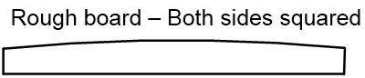

1. Adjust depth of cut no more than 1/16” I typically use 1/32” as it as not as hard on the cutter blades
2. Repeat until desired board thickness is achieved.

**Congrats….you now have a flat and straight board!!!!!!**

